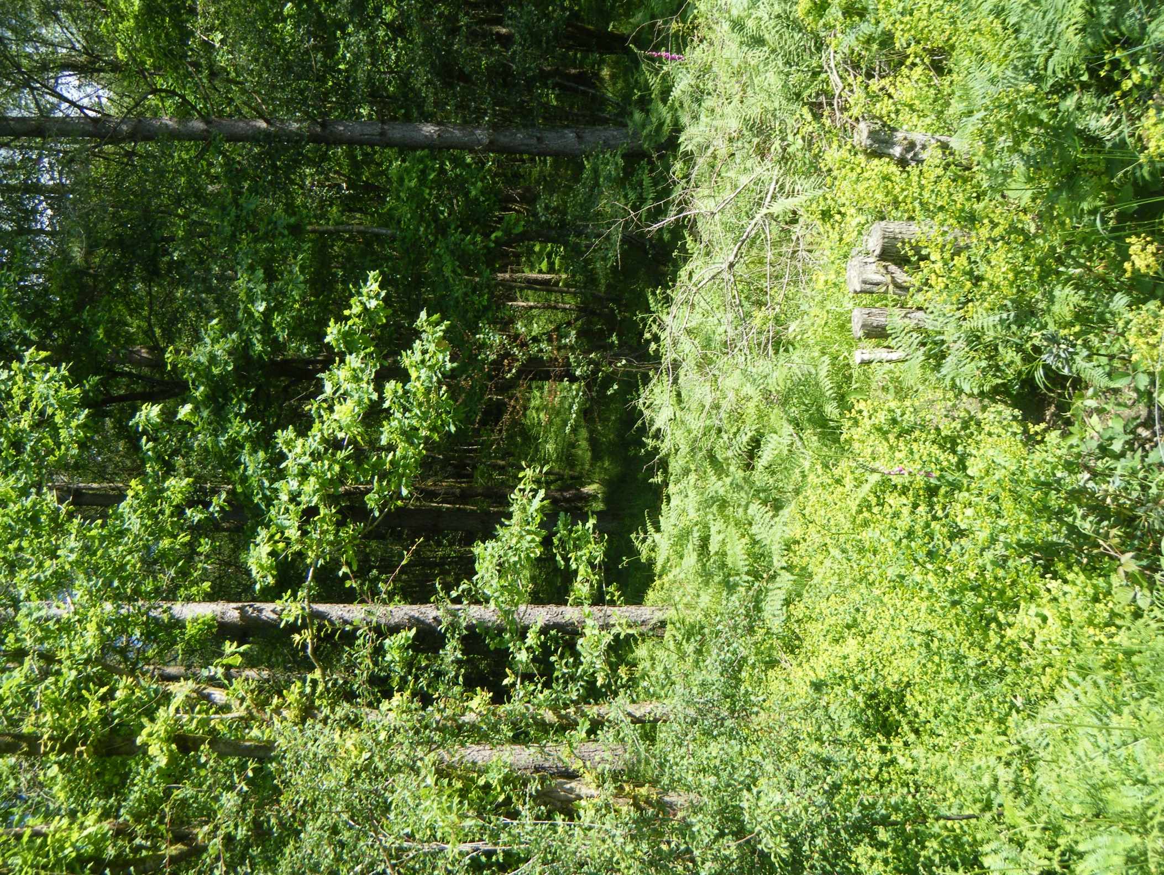
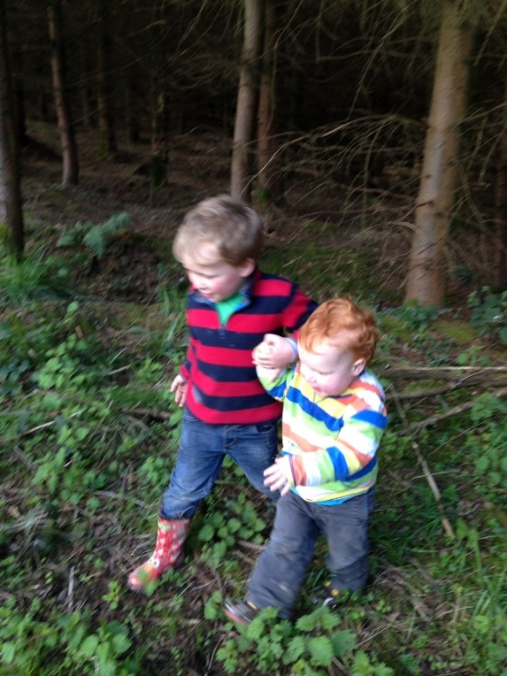
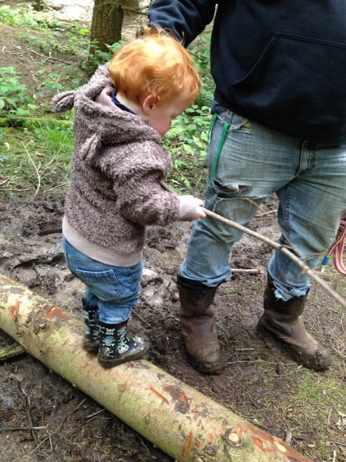
Holiday Club
Operations Handbook
Version 1 – Nov. 2019

Contents
- Introduction
  - A brief history
  - What we offer

- Operational Procedures
  - Session Operating Procedures.
  - FAQ for parents and volunteers.
  - Role of the Leader.
  - Role of session helpers.
  - Role of participants.
  - Daily Risk Assessment Procedures.
  - Communication and contact.

- Operating Policies and Procedures
(see separate index)

- Risk Assessments (see separate index)

- Form Masters

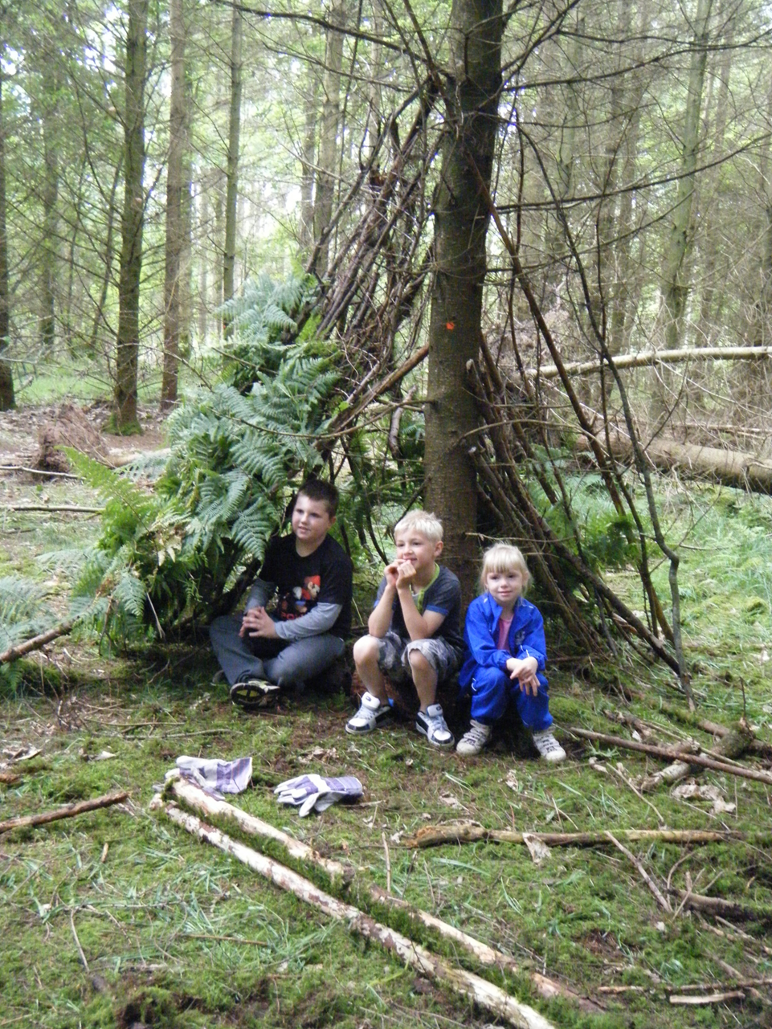
- Introduction
1.1 A Breath of Fresh Air – A brief history

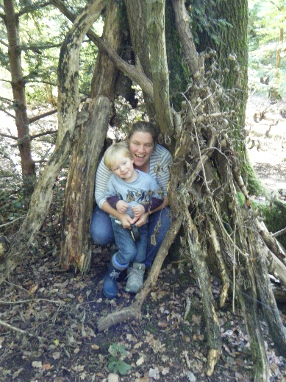
‘A Breath of Fresh Air’ is owned and managed by Sarah Tawse. I have previously worked as a Countryside Ranger for over 15 years, before having my own family, and beginning my Forest School Training. I have worked for a range of countryside organisations including council run Countryside Services, Suffolk Wildlife Trust and the Trust for Conservation Volunteers. Previous roles have included countryside management and outdoor education, I have developed and led a range of community engagement projects, focused around young people and attracting communities that are under-represented within the countryside.
I have been working as a freelance Forest School and Outdoor Learning Practitioner since completing my training in 2014, where I have experience in leading a range of ages and groups from toddlers to adults. Since January 2017 I have been developing a training programme through an accredited provider to deliver quality training and CPD opportunities for those wanting to engage children and young people in the outdoors.
Above all I have a passion for connecting children with nature and providing a range of experiences that encourage them to explore and discover the natural environment.
I work with a team of freelance professionals and volunteers wanting to gain experience during their training to deliver sessions across sites. Everyone working with ‘A Breath of Fresh Air’ must hold a current DBS, relevant qualifications to the activity they are undertaking, a current first aid certificate and public liability insurance. Trainees and volunteers who don’t hold the required certification must be working on site with a fully qualified leader and may be covered by our Employers Liability Cover.

- Throughout this plan we refer to our onsite partners as FC (Forestry Commission). In 2019 during a national restructuring they are now referred to Forestry England.

1.2 What we offer
‘A Breath of Fresh Air’ offers a range of activities to encourage all elements of the community to engage with an outdoor experience.
Through these experiences ‘A Breath of Fresh Air’ aims to:

- Build self-esteem, independence, motivation to learn whilst always maintaining a safe environment.
- Promote awareness, respect and care for other individuals and for the natural environment.
- Reinforce collaborative behaviour.

1.2.1 Outdoor Learning
A Breath of Fresh Air- works in partnership with the Forestry Commission (FC) to deliver Outdoor Learning at the Wyre Forest. We have secured the contract to be the main learning provider onsite for 5 years from April 2015. The aim is to deliver structured learning opportunities to school groups and uniformed groups to deliver the FC’s Learning message. Through a comprehensive programme of curriculum linked activities see appendix.

We also provide the following activities to engage as wide an audience as possible:
- Birthday Parties
- Go Wild- drop off sessions for over 5’s.
- Toddler Forest Play- Parent and toddler sessions during term times.
- Family Forest Adventurers- Family sessions holidays and weekends.
- Boys in the Wood-Male carers and children session. Monthly.
- Drop in Family Activities and promotional events.
- Adult Learning opportunities and outdoor experiences.

We have a three year business plan which is reviewed annually with the aim to increase learning visitors to the site to 6,000 by the end of year 3 (2018). Since 2018 we have gained a further 3 year contract to run activities. See Business Plan Review for updated data.
We also provide a programme of Outdoor Learning and Forest School Training. Working in association with Cambium Sustainable to deliver accredited level 1-3 courses.

1.2.2 Forest School
Forest School is offered on a freelance basis across the West Midlands.
Who is the Forest School audience?
- Deliver pre-planned and organised sessions to Primary, Secondary school aged groups, during term time.
- To provide Forest School style activities as short course sessions during school holidays and as after-school activities.
- To provide forest school style activities to wider members of the community to develop benefits for social and personal development i.e. to promote health and wellbeing clients referred by a G.P.
- Open to all sections of the community, advertised through local community portals including schools, children’s centres, youth groups, health and wellbeing groups and the PCT.
- To include sessions for parents and carers to extend the benefit of Forest School and to understand it’s processes.
What is Forest School?
Forest School is more than just ‘getting children outside’. It is a philosophy to encourage children to develop as individuals. Encouraging young people to develop self-confidence, self-esteem and a sense of place within a community, developing practical skills and knowledge inspired by exploring nature.
A fundamental principle of forest school is to be participant-led. Activities and individuals learning are guided by their own interests and exploration of the natural environment. Through a short period of 12 sessions participants will be observed and challenged by developing their particular interests (schemas). A schema is based on observations of learning generally through play. If learning is developed in line with that person’s preferred schema(s) it can enhance or accelerate the learning process, as traditional barriers within the teaching environment have been removed. Schema’s have been very closely researched and relate to advances in neurological science to understand how we learn and develop.

History
Forest Schools developed in Scandinavia, where children from an early age spend a significant proportion of their schooling outside (in all weathers). Learning developed through a range of practical skills and study of the natural environment. Forest School was brought across to Britain in the 1990’s where it began to be developed in nurseries. There has been a swell in the Forest School movement in recent years where the benefits of child-led, outdoor activities have been promoted through schools. Helping to reconnect young people with nature as an antidote to ‘nature-deficit disorder’ (Louv 2005) and the wider promotion of opportunities for children to explore and play in the outdoors.

1.2.3 Ofsted registered holiday club

In 2018 we applied to an Ofsted registered Holiday Childcare provider. To provide a core and wrap around care for primary aged children (rising 5’s and over). Being Ofsted registered allows us to offer more hours and means we can accept Childcare Vouchers and funded places for rising 5 year olds. We are hoping to offer this from Easter 2020.

The core hours of the provision will aim to cover school hours from 9am-3.30pm. For primary aged children.

Once we have obtained our Ofsted registration, we are looking to offer additional wrap around provision before and after these times. This will extend possible provision to between 8am-5pm, for an additional charge.

Our core holiday care is offered as outdoor provision based within the learning area of the Wyre Forest. There is a covered fire/seating area, used for storage of bags, eating snacks and lunch, and in case of bad weather.

Children should come prepared to be outside for the day. Please see suggested kit list. They should be provided with adequate clothing and spares, a drink and snack.

We also have use of an indoor room space, if weather becomes too bad to continue sessions outside (this would be extreme wind, thunder and lightning), and used for wrap around care options when they become available.

A healthy campfire lunch will be provided as part of the session, snacks and drinks will also be available, during the day.

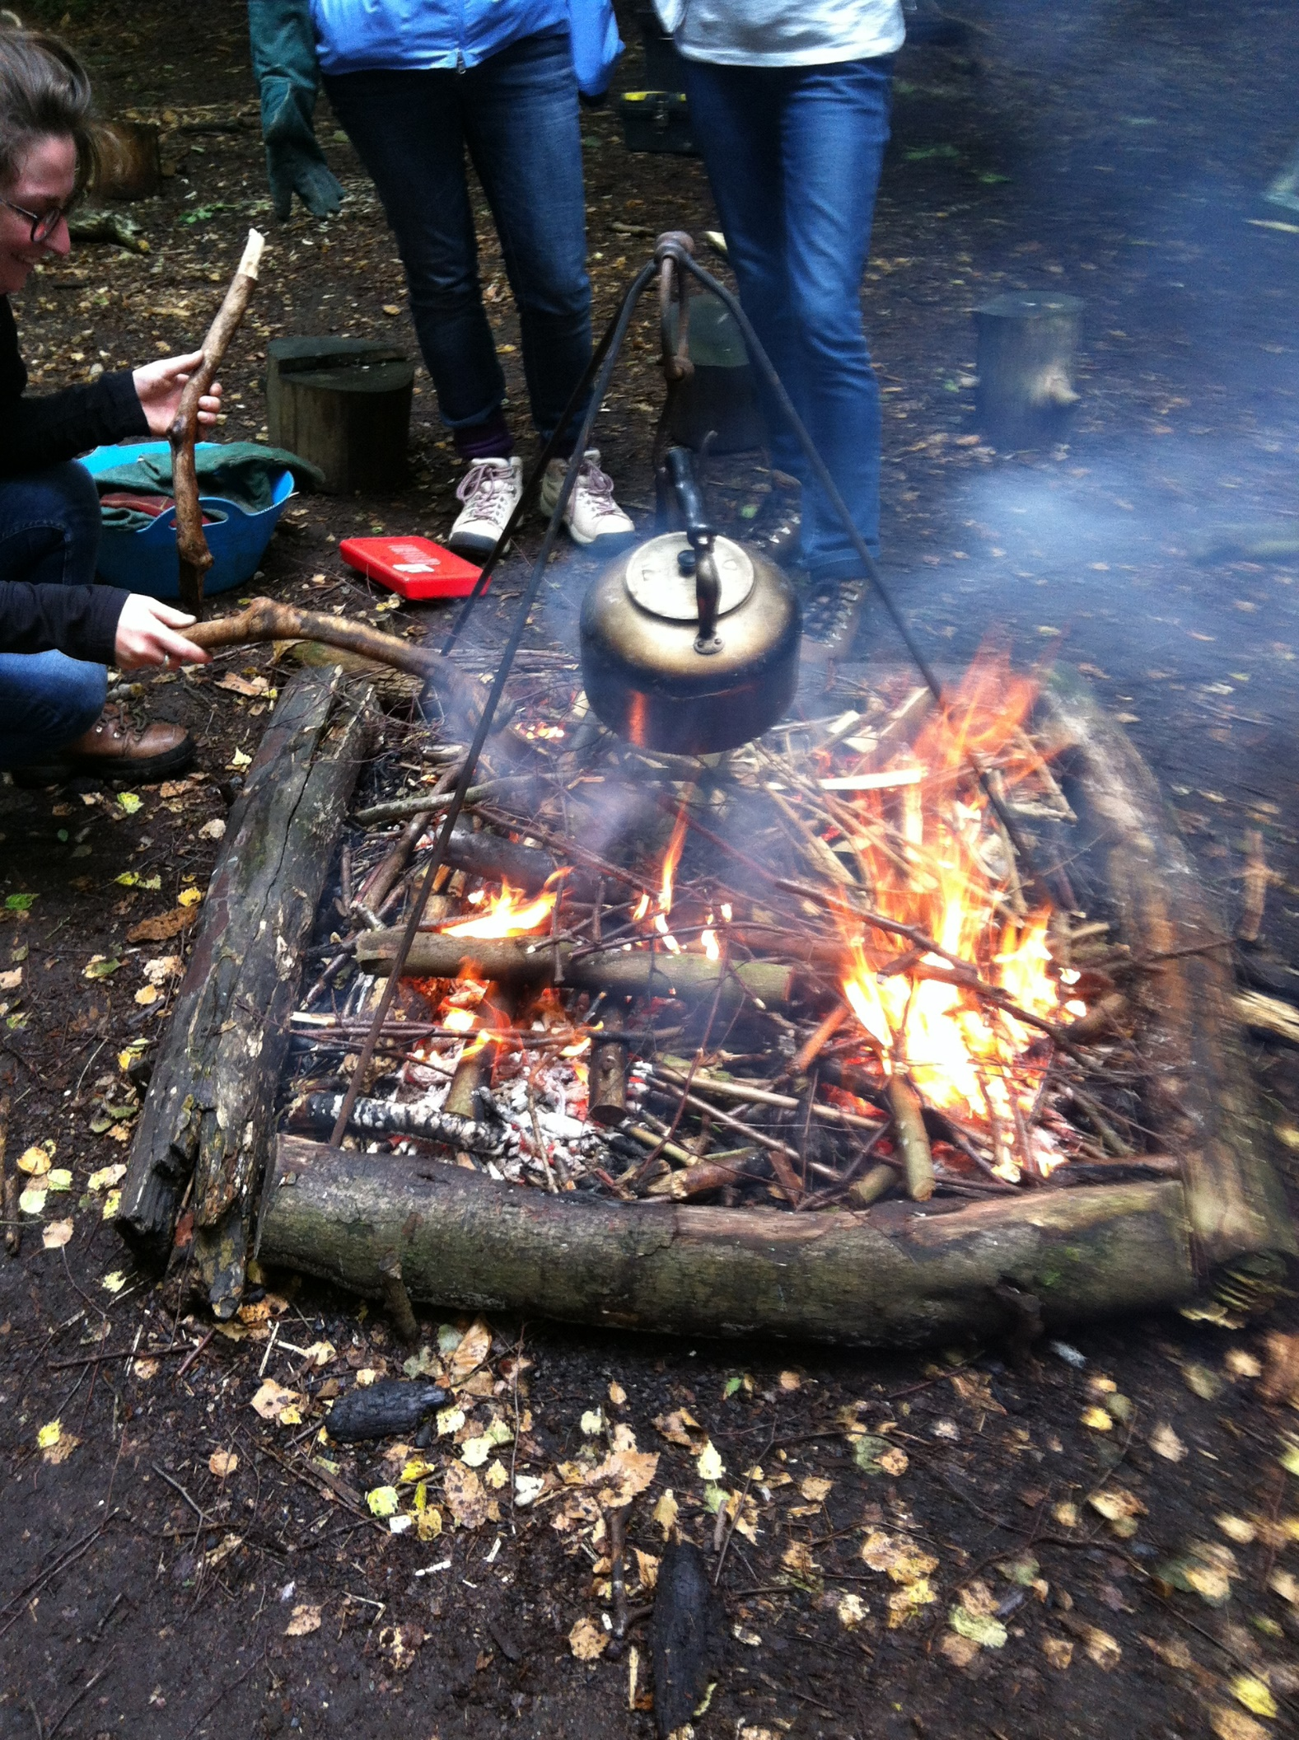

2. Operational Procedures
2.1 Holiday Club Operational Overview
These are events where parents don’t stay with their children. They are dropped off for a core session from 9am-3.30pm.
2.1.1 Booking
Bookings are taken via the website or phone. Sessions must be paid for in advance an invoice can be sent if easier. At time of booking a parental consent form will be sent along with joining instructions for the session.
Parental Consent Form
There is a full parental consent form, which must be completed if ABOFA is being left in sole charge of the child and the parent/carers will be away from site. The form records full name, date of birth, name and address of parent/carer and emergency contact details. These must be kept in the Operations Folder with the leader at all times during the session. They can be used for subsequent sessions as long as the parent/carer confirms that the emergency and medical details have not changed, or the form should be updated as appropriate. These forms need to be kept in the session folder and stored to be compliant with GDPR guidelines.

2.1.2 Dropping children at session
We meet at 9am outside the café. We will wait until all participants have been dropped off before moving around to the education area or starting activities for the day.
The sign in sheet must be filled in with the parents as they hand over their child.
It is important that signing in sheet is used to verify information such as emergency contact details and medical information, and parents/carers can discuss any issues which may be vital to the running of the session.
2.1.3 Collecting children from session
Children should be collected at 3.30 pm from outside the café. Children should be marked off the sign in sheet as they are collected. Any matters arising during the course of the day should be discussed with the parent/carer. If any children are left uncollected then the Uncollected Child Policy should be followed.
2.1.4 Wrap around care
Wrap around care will operate out of the smaller Discovery Centre – collection and drop off for this session should be directly at the centre. This ensures that children stay safe as they are collected and dropped off. Parents/carers will be asked to sign in and out as appropriate.

2.2 General FAQ’s for parents and volunteers
2.2.1 Toileting on site
Activities take place on a range of sites with varying facilities. Each site/group will be assessed on their own merits to establish a toileting policy. Ideally sites will have full facilities and participants will be able to use these before a after a session.
Some sites will be remote and toileting will be appropriate on site. Children and young people are allowed to use designated areas of the wood and are told how to do so with due care and consideration to hygiene, care for the environment and personal privacy.
There is no running water, but for each Forest School session there will be a container of water on site. Hand wash, towels and antibacterial wipes will also be available.
2.2.2 Clothing
It is an important part of the ethos of Forest School that activities take place ‘what-ever the weather’. Instilled within this ethos, is Maslow’s Hierarchy of needs (Maslow 1962). A simplified schematic, whereby personal development can only happen once a hierarchy of basic needs are met. The basic criteria are for food, water, security and belonging. This can be facilitated by ensuring the participants are adequately prepared to be outdoors, by:
- Wearing clothes they don’t mind getting dirty as they will be sitting on logs, kneeling on the ground, lighting fires and collecting natural materials.
- Wearing long sleeves and trousers whatever the weather, this helps prevent sunburn or being stung/prickled by plants and insects. Long trousers and sleeves are also essential to reduce the chances of picking up ticks, if present on site.
- Stout shoes should be worn suitable to protect the feet in rough and uneven terrain.
- Waterproofs will be required as the session will run in all weathers this includes waterproof trousers and a coat with a hood.
- In the event of bad weather or prolonged sunshine a shelter will be erected on site.
We may be able to provide additional clothing and footwear. The provision of appropriate clothing should not be seen as obstructive to attending sessions. We will help as much as we can to ensure that children have the minimum requirement of clothing to be able to attend sessions.

2.2.3 Dropping off and picking up participants
Participants will need to sign in with the leader on arrival. This requires parents/carers to sign the daily register when dropping off and collecting the child/participant. Group leaders will be responsible for ensuring that their children leave with the appropriate parent/carer at the end of a session. If someone different will be collecting your child then it is your responsibility to identify this to the leader when dropping off the child. Children will not be released to ‘strangers’, additional carers can be identified using a pre-identified password if agreed with a parent and leader in advance. A registration form must be completed before signing on your first session.
2.2.4 First Aid/Emergency Procedures
All leaders are emergency first aid trained and ‘A Breath of Fresh Air’ has a full emergency procedure and policy. When filling in the registration form you will be asked to sign to say you give permission for emergency first aid treatment in the event of an accident/emergency. Trainees or volunteers may not have completed First Aid Training, but must only work on site with a fully trained leader present.
2.2.5 Eating and Drinking
Some sessions will include the provision of snacks/lunches. This will be highlighted in any relevant literature. This may include eating from the wild. Though for younger groups the children will not be encouraged to collect and eat wild foods, but market substitutes will be brought in. Hygiene is of the utmost importance and the group will have facilities to clean their hands before eating. Any food will be prepared and stored using appropriate storage and preparation facilities. Any allergies/dietary requirements should be mentioned on the registration form.
2.2.6 Fires
Fires are used as part of the Forest School process but will not be introduced until the group is deemed ready by the Forest School Leader. We have strict policies and guidelines on the protocols of having a fire. Fires will only take place in a designated area. The group is ‘trained’ in appropriate behaviour and procedures to make the experience of lighting, cooking with and enjoying fires as safe as possible.
Normally a designated area for fires will be present within a Forest School site. Seating will be arranged for the children to sit on at a safe distance from any fires lit. The children and young people will be encouraged to walk around the outside of the designated area at all times and they will not approach any fires unless specifically supervised to do so. Water will always be available to safely extinguish fires and the fire site will be designed to reduce the risk of any spread of fire.
2.2.7 Use of tools
Forest School uses a variety of hand tools to explore and develop skills. These include bowsaws, knifes, loppers and billhooks. These will only be introduced when appropriate to the group. Strict policies and procedures are in place to guide the leaders’ decision to introduce these elements, and their approach to using tools in a safe manner developing good practice.

2.2.8 Risk Taking
The development of self-esteem, confidence and independence hinges on the ability of the participant to challenge themselves, this allows them to develop their own learning in how to take and manage reasonable risks. Policies and risk assessments are in place to make sites and activities as safe as possible. Activities are also assessed for their ‘risk benefit’. Risk benefit identifies the benefits to the individual by undertaking an activity- such as tree climbing to head height. The activity allows individuals to push their own boundaries through climbing to height, develops co-ordination, logic skills to find a route, physical activity, provides a sense of achievement when successful.
In order for activities like this to run safely, any adults involved must know their role and ensure that the necessary risk assessments are carried out regularly and thoroughly. Parent Helpers/Volunteers should ensure they carry out the rules below and observe the policies and practices contained within this handbook.
2.2.9 Parent/Volunteer helpers
Any helper needs to be DBS checked before they are able to help and needs to fully read the handbook including policies and procedures and risk assessments for relevant activities. The handbook includes clearly defined roles for the leader and helper. All adults involved with the sessions need to be committed to observe the ‘ground rules’.
2.2.10 Weather
Assessments of weather conditions will be taken prior to a session and if the weather is too extreme the session may be cancelled. In the case of severe weather conditions the site may be shut. Where possible, alternative indoor provision will be arranged. If the weather deteriorates suddenly during a session, the adults will decide whether to leave the site, use alternative accommodation. When windy and there is a danger of falling branches, the children will be taken to an alternative setting.

2.2.11 What do we need to bring?
Please see the kit list for advice on what to pack/bring.

2.3 | Role of the Leader

Responsibilities of the session Leader are:

- To plan and lead all activities, within the constraints of the type/style of session that is on offer.

- To ensure that planned activities are within the capabilities of the children taking part, amending plans to provide an inclusive curriculum in its broadest sense.

- To take responsibility for discipline during sessions (see Behaviour Policy).

- To have an up to date First Aid qualification, DBS certificate and appropriate insurance.

- To ensure that all participants follow the Clothing Policy.

- To carry out daily risk assessments as described in the Risk Assessment Policy. To follow any policies and procedures contained within this handbook.

- Leaders assume responsibility for the maintenance of their First Aid Kit, Kit Bag(s) and any tools and equipment used in the session.

The Leader will:
  - Create a positive environment which encourages and reinforces caring, nurturing and acceptable behaviour towards one another, the environment and equipment.

  - Promote effective relationships in which all are accepted, valued and treated equally

- Ensure the provision of sufficient information and instruction for all adults so that they can contribute to their own health and safety and that of the children they are working with.

- Establish and be utterly familiar with, all emergency procedures including the reporting and recording of procedures.

- Ensure that risk assessments and pre-site visits take place before children are permitted on to the site.

- Ensure alternative plans are in place should a planned activity be compromised by health and safety concerns.

- Investigate any accidents and use information gathered to inform future risk assessment and policy making.

- Teach all members of the party to maintain their own and others health and safety by involving them in the risk assessment process at appropriate opportunities.

- Maintain as a minimum the legal adult-child ratio.

- Ensure that safety equipment/tools/resources are in good working order and are used appropriately.

2.3.1 Leaders Kit List

Leaders Kit List (including first aid kit)

- Bag
- First aid kit
- Burns Kit
- Fire Blanket
- Survival Blanket
- Whistle
- Pen/paper
- Spare clothing/hats/socks (for participants)
- Emergency snack (for participants)
- Drinking Water
- Emergency Plan – inc. important contact numbers
- Group medical and emergency contact numbers inc. leader.
- Copy of risk assessment

2.4 | Role of the session helpers
All trainees and volunteers need to apply and be checked by the DBS under a standard disclosure. They must be covered by insurance. They should have had some initial information and training. They will be involved setting up the site and transporting kit, all activities during sessions and helping to make observations and plan future sessions. They must accept the restrictions of their responsibilities and be aware that the leader holds overall responsibility. Any conflict of interest should be discussed after sessions.
2.4.1 Additional Helpers/Volunteers
Other adults should be clear in their roles and responsibilities. They must:
- Do their best to ensure the health and safety of everyone in the group.
- Not be left in sole charge of children. Follow the instructions of the leader and teacher adults and help with the control and discipline.
- Speak to the leader/adults if concerned about the health and safety of children at any time during the visit.
- Observe the guidance for teachers and adults.

Duties can include:

Before session
- Helping with site check and clearance (including toilet facilities)
- Getting kit ready and helping to transport it to site
- Meeting group and helping with outdoor clothing as they arrive

During session
- Help with all activities
- Help with keeping the fire going. Be aware and ensure all safety procedures are adhered to.
- Helping with snacks and drinks when there’s a break
- Supervision of tool use
- See group onto minibus and collect outdoor clothing
- Make observations to be discussed after session

After session
- Help with site clear up (include toilets) and putting fire out safely
- Help with sorting and cleaning clothing and equipment
- General discussion about the day and suggestions for future sessions

2.5 | Role of the participant

- Participants to the best of their abilities and with or without support will:
Listen carefully and respond to instructions and requests, especially those concerning safety.

- Develop and maintain an acceptable attitude towards one another, the environment and all equipment.

- Look out for anything which might be a threat and tell an adult about it.

- Bag- suitable size for the kit.
- Spare clothing/hats/gloves/socks/pants/trousers and jumper.
- Waterproofs (even if dry as weather changes)
- Snack (In case they don’t like camp food).
- Drinking Water.
- Plastic bag to return and muddy/wet clothing.
- Wearing ideally long sleeves and trousers whatever the weather. To protect from stings, bites, protection from vegetation and Ticks.
- Stout, sturdy shoes. Not open toed shoes. If wearing wellies and gloves a plastic bags on between layers of socks helps keep feet warm and dry.

2.5.1 Participant Kit List

2.6  2.7  2.7.1  2.7.2  2.7.3  2.8.5 | Daily Risk Assessment Procedure  Leader(s) must complete a daily risk assessment of the site before the start of the session. This is to include a visual inspection of the site, checking and removing hazards as appropriate. If the site is deemed unsuitable for the chosen activities that day (because of safety issues) then the leader should either select an alternative location or activity as appropriate.  At the Wyre the FC are responsible for the tree safety onsite and ABOFA should only use the areas highlighted on the Learning License Agreement (see separate document). The FC may close the site in response to weather warnings if the site is deemed unsafe for public access.  Communications  It is important to maintain effective and open communication pathways between all involved with Forest Learning (leaders, parents, participants, volunteers and the wider community) to demonstrate and share effective learning and positive outcomes that outdoor learning provides and can be shared back in the home environment, where appropriate. Also to ensure that any problems that may arise are dealt with swiftly and in an appropriate manner.  Communications to parents  We aim to maintain clear open lines of communication to all of our parents/carers as appropriate to the session. We provide clear information on what to expect from the sessions via our website, booking forms and confirmation documents.  Information to parents should include:  How the EYFS is delivered for those children not in full time education.  The range and types of activities delivered.  Daily Routines. How we support SEN and disabilities. Food and drinks provided. Our policies and procedures, these will be available on our website and paper copies will also be available.  We evaluate our Forest Learning sessions through a variety of methods, onsite review with users, formal questionnaires and informal feedback this is collated and regularly reviewed, with procedures and policies to be updated as appropriate.  Communication for staff/volunteers  Communication between leaders and volunteers should take place before and after each session as part of a review process. This is opportunity to share experiences and observations, and any ideas for future activities.  If there are any problems between staff/volunteers these should be worked out amicably and resolved swiftly, if this cannot be done then the complaints procedure should be followed.  Communication within the wider community  ‘A Breath of Fresh Air’ aims to develop a series of open days to promote Outdoor Learning/Forest Schools to the wider community.  We will produce and use a website to promote and highlight activities, giving a wider explanation of FS and OL what it is/does. As well as the use of social media to promote opportunities.  Communication with participants  At Forest School sessions - Informal reviews will happen as part of each session usually around the campfire. This will be a chance for participants to explore what they have experienced/learnt/developed as part of that session and throughout the whole experience. It will give the leader and others the chance to hear how individuals feel about the process and reflect on their own learning and develop empathy for others. This information will help leaders to reflect and review activities and guide the content of future sessions.  The nature of FS to allow relationships to develop and close bonds to form enhances and allows individuals to explore their own feelings and sense of self, which in turn promotes self-esteem and self-confidence of the individual.  During outdoor learning sessions formal evaluation sheets will be given to group leaders at the end of the session. There is also a form for children to complete, if the opportunity arises. Monitoring and Evaluation forms part of our agreement with the FC, so it is important to encourage group leaders to complete the forms.  Expectations of the trainer and trainees, and Access to Fair and Reasonable Adjustments.
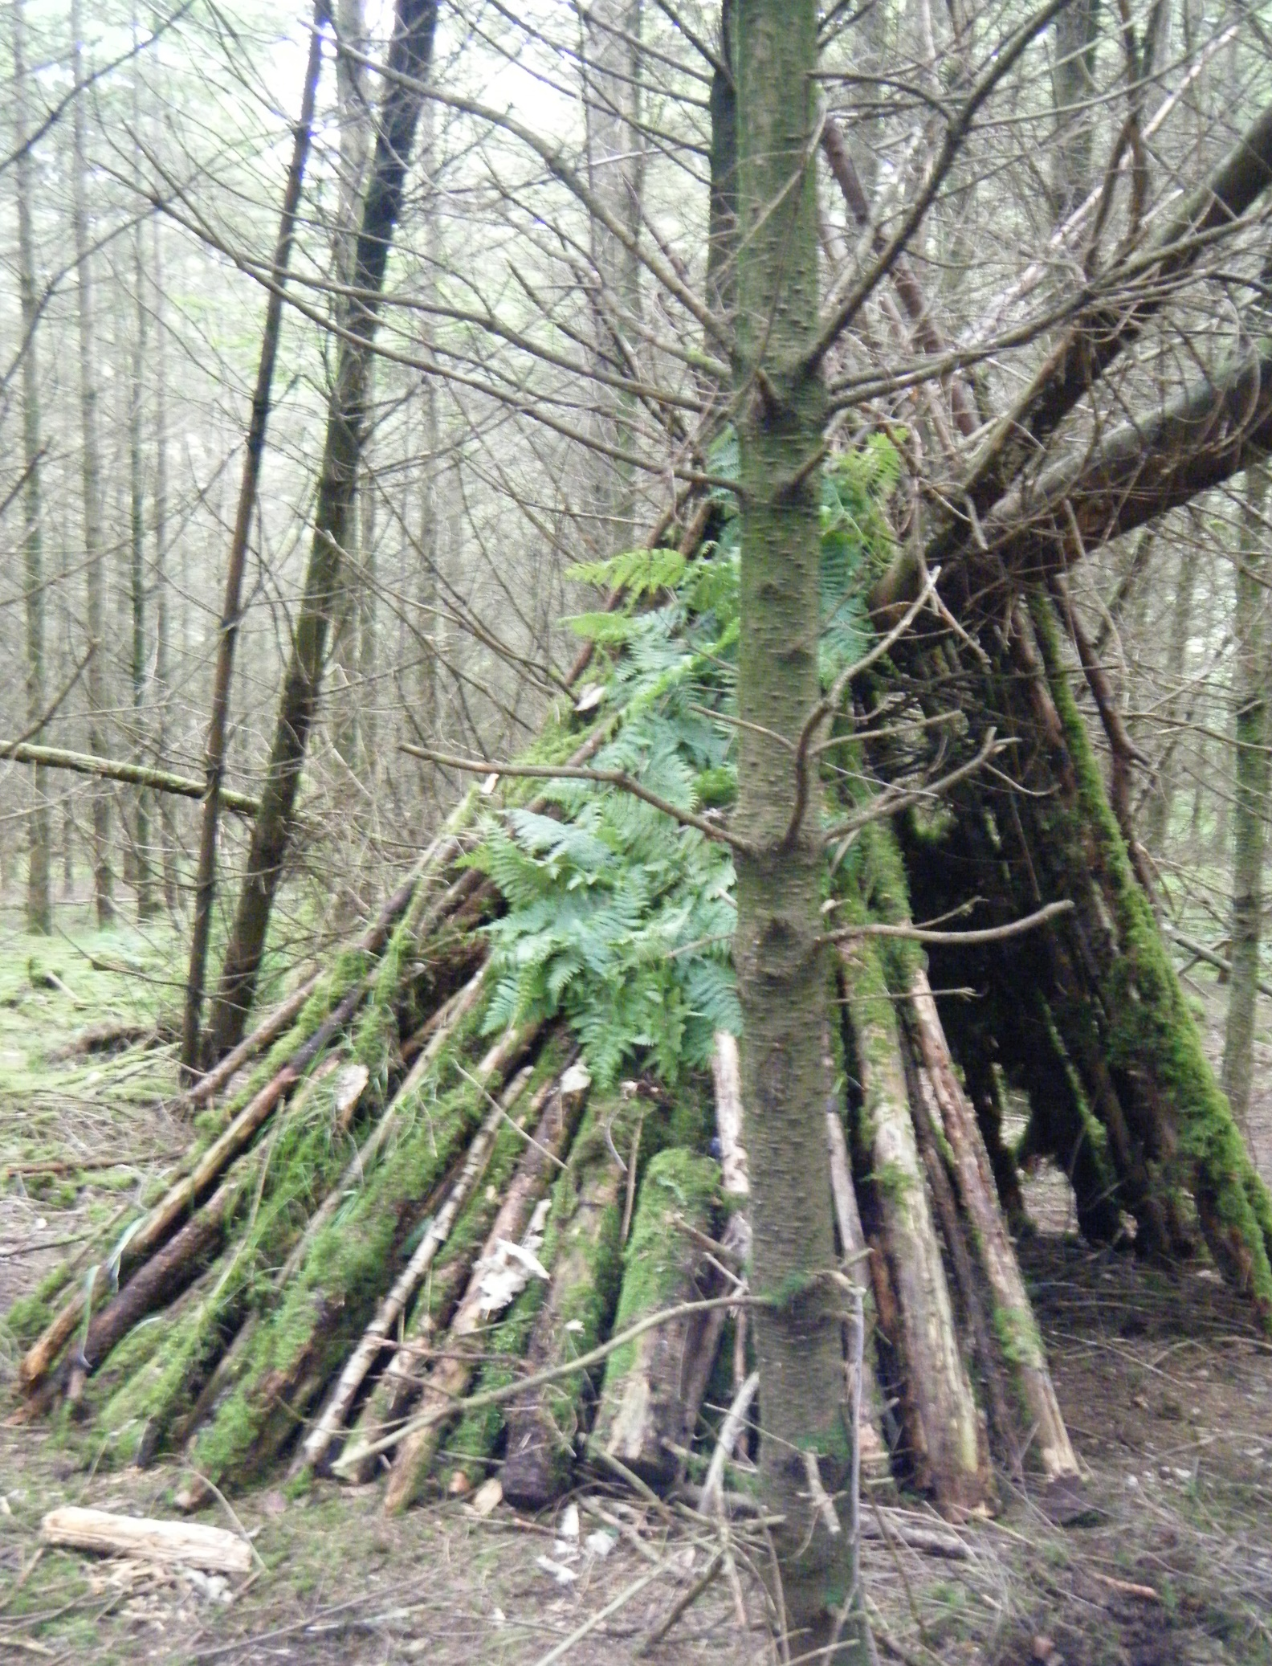
3. Policies and Procedures
Policies Index
P1- Admissions to Family Activities, Schools and Groups
P2- Arrivals and departures
P3- Accident Procedures
P4- Administration of medicine
P5-Behaviour
P6-Cameras, Mobile Phones and Media Devices
P7- Child Protection/Safeguarding
P8- Clothing Policy
P9- Complaints
P10- DBS Policy
P11- Confidentiality
P12- Data Protection Policy
P13- Emergency Plan
P14- Equal Opportunities
P15- Equipment and Resources
P16- Fire
P17- Food and Drink
P18- Health and Safety inc. First Aid
P19- Toileting
P20- Missing Child Procedure
P21-Transport
P22- Volunteers
P23- Tool Use
P24- Disposal of waste
P25 –Weather
P26 – Sustainability
P27 – Fees Policy

Policies Index
P28 – P36- Training Policies
P37- Uncollected Child Policy
P38- Recruitment Training and Qualifications for Staff
P39- Expected/Unexpected Visitors and movements offsite
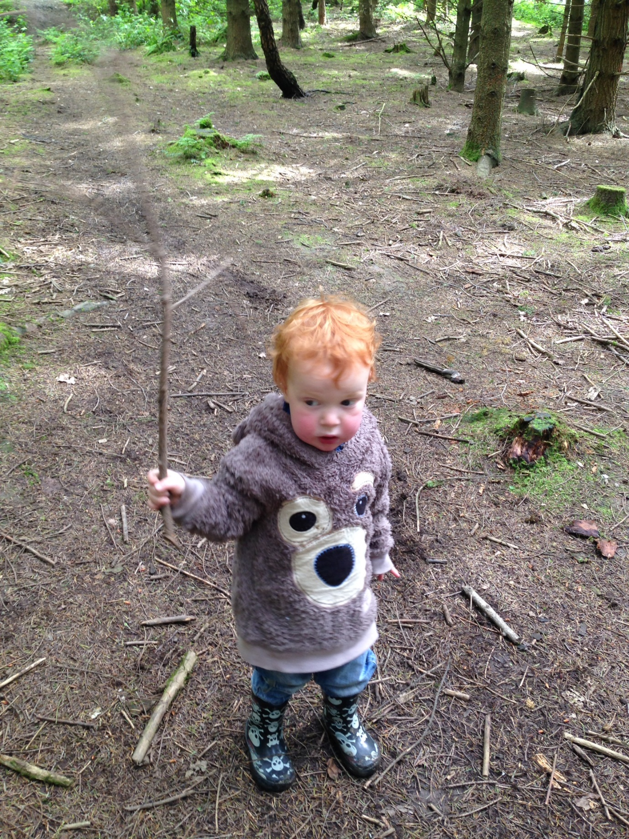
4. Risk Assessments
Risk Assessment Index
- General Site Assessment
- Weather General Welfare
- Working with a group
- Working with individuals
- Transport and Travel
- Fire
- Water
- Collecting Natural Materials
- Being off the ground
- Blindfolds
- Tools general use of
- Billhook
- Bowsaw
- Sheath Knife
- Mallets
- Potato Peeler
- Loppers
- Shelter Building
- Rope and String
- Muddy Play
- Hammocks
- Firing Weapons- Bows and Arrows/Catapults
- Folding Saw
- Food Hygiene (see separate Food Standard Agency document and Diary)
Session Risk Assessments
General Wyre Site Assessment
Holiday Club

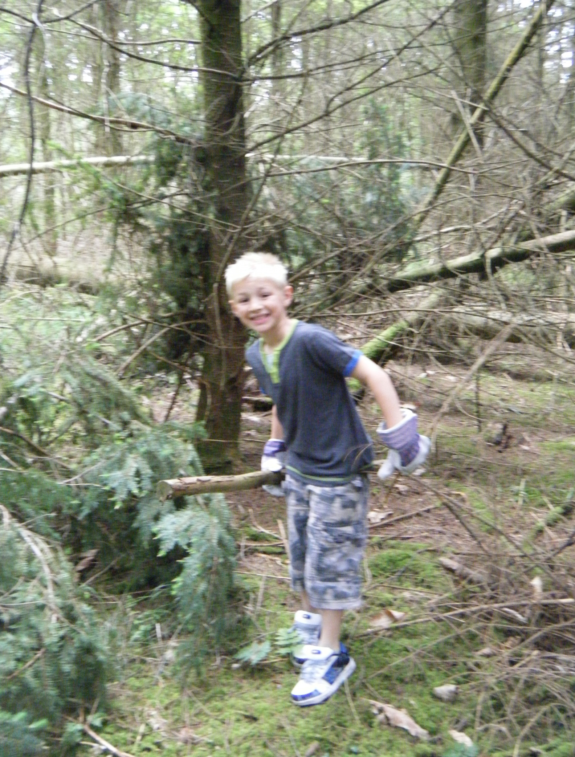
5. Pro-forma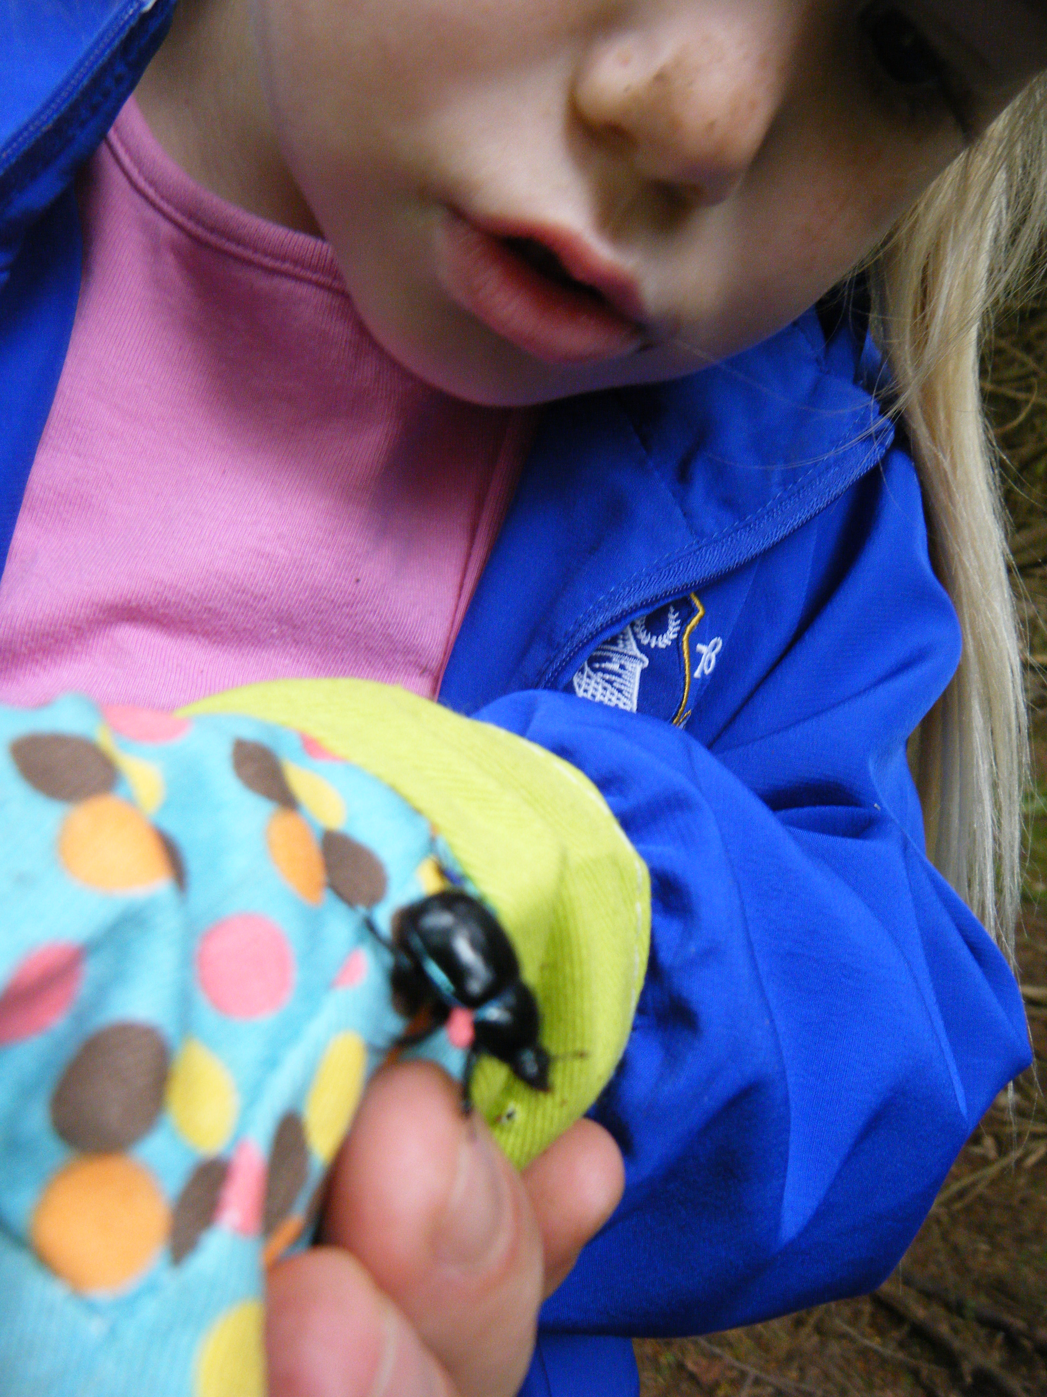dard Forms

Pro-forma

